

Yedi Risdianto | 200511033 | TI20D

Tugas 3 : Membuat aplikasi konversi celcius, Fahrenheit dan reamur

1. **Konversi Reamur ke Celcius, Fahrenheit, dan Kelvin**

Source Code :

Public Class ConvertReamur

Private Sub btnConvert_Click(sender As Object, e As EventArgs) Handles btnConvert.Click

Dim R, C, F, K As Decimal

R = CDec(txtReamur.Text)

C = ToCelcius(R)

F = ToFahrenheit(R)

K = ToKelvin(R)

txtCelcius.Text = Str(C)

txtFahrenheit.Text = Str(F)

txtKelvin.Text = Str(K)

End Sub

Private Function ToCelcius(suhu As Decimal) As Decimal

Dim C As Decimal

C = (5 / 4) * suhu

Return C

End Function

Private Function ToFahrenheit(suhu As Decimal) As Decimal

Dim F As Decimal

F = (9 / 4) * suhu + 32

Return F

End Function

Private Function ToKelvin(suhu As Decimal) As Decimal

Dim K As Decimal

K = (5 / 4 * suhu) + 273

Return K

End Function

End Class

Hasil Program Konversi Reamur ke Celcius, Fahrenheit, dan Kelvin:

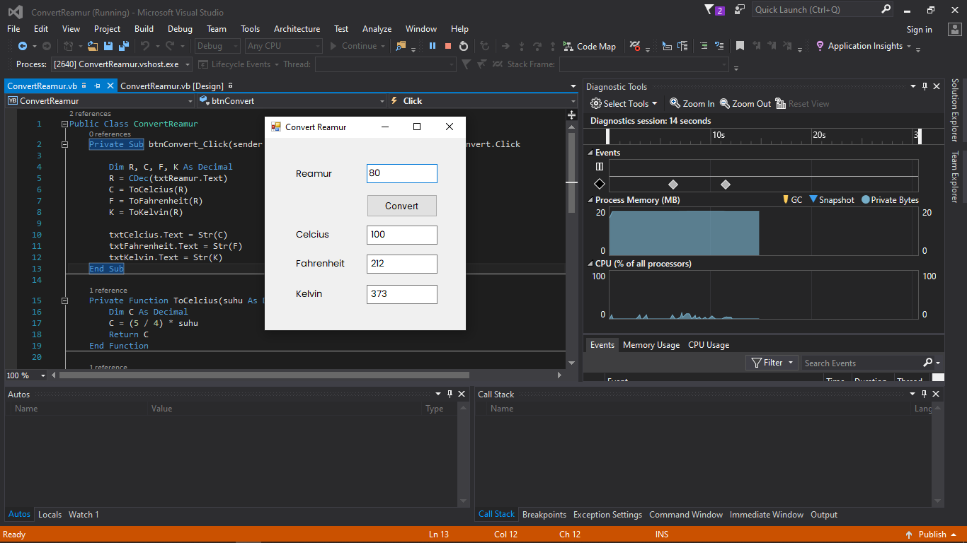

1. **Konversi Kelvin ke Celcius, Fahrenheit, dan Reamur**

Source Code :

Public Class ConvertKelvin

Private Sub btnConvert_Click(sender As Object, e As EventArgs) Handles btnConvert.Click

Dim K, C, F, R As Decimal

K = CDec(txtKelvin.Text)

C = ToCelcius(K)

F = ToFahrenheit(K)

R = ToReamur(K)

txtCelcius.Text = Str(C)

txtFahrenheit.Text = Str(F)

txtReamur.Text = Str(R)

End Sub

Private Function ToCelcius(suhu As Decimal) As Decimal

Dim C As Decimal

C = suhu - 273

Return C

End Function

Private Function ToFahrenheit(suhu As Decimal) As Decimal

Dim F As Decimal

F = 9 / 5 * (suhu - 273) + 32

Return F

End Function

Private Function ToReamur(suhu As Decimal) As Decimal

Dim R As Decimal

R = 4 / 5 * (suhu - 273)

Return R

End Function

End Class

Hasil Program Konversi Fahrenheit ke Reamur :

